**QUOTATION:**

1. Required Fields

* Date – automatic
* Quotation Number – Auto
* Revision No. – Data Entry
* Customer Code: Data Entry
* Country: Drop Down List
* PriceList – Drop Down List to select what pricelist to be used.
* Order Item - Drop Down List (Information from Products Database), up to 300 entries- pls confirm.
* Specification – Data Entry
* Quantity – Data Entry
* Unit Price – Vlook Up from the selected price list
* Line Total – Qty X Unit Price
* A. Sub Total – Sum of Line Total
* B. Shipping Fee – Data Entry
* C. Bank Charge – Data Entry
* D. Discount – Data Entry must be negative
* E. Others – Data Entry
* Total – Sum of A,B,C,D,E
* Method of Payment – drop down list: bank, agent, money transfer, cash
* Shipping Method - drop down list: DHL, UPS, Fed Ex, Agent, Pick Up
* Customer Service Instructions – Data Entry

Feedback:

* Quotation print out/screen display does not show the item description, specification, quantity and price. It is very important to show this. Please check our format. You can create a better print out as long as the required information can be seen.
* Quantity must be a decimal number with one decimal places.
* The system must allow file upload.

1. Requirements:

* Creator’s initials must be shown on the document.
* Sales Order can be generated from quotation.
* Quotation cannot be revised on the next day.
* Quotation can be duplicated.

1. Report:

* Summary of Quotation – can be filtered according to date, customer code, country and order item.
* All reports must be downloadable/printable in excel and PDF.

**SALES ORDER:**

1. To create Sales Order, generate from the quotation. Please see Sales Order Format.
2. Required Field:

* Customer Code changes from data entry to drop down list (Information from Customer Database)
* Sales Order No. – System Generated. Format YYYY.MM.###
* Add Revision No. – drop down list: R1, R2, R3, R4, R5
* Add Due Date – select from calendar
* Add Date of Revision: automatic

1. Requirements:

* There must be an Order Confirmation button to confirm the Sales Order.

If not confirmed SO created stays on drafts.

* From the CONFIRMED Sales Order, Invoice and Job Order can be generated.
* Sales Order and Invoice have the same format and series no., **only the document name changes.**
* INVENTORY UPDATES: Order quantity **adds** to order requirement per product.
* Creator’s initials must be shown on the document.
* All revisions must take effect on the Job Order too.
* Printable/downloadable files must be in excel and PDF.
* Sales Order can be duplicated.
* Cancelled Sales Order will automatically cancel Job Order and all stocks reserved to it.
* Payment uploaded on the Cancelled Sales Order can be just adjusted manually by encoding the new Sales Order No.

1. Report:

* Summary of Sales Order – can be filtered according to date, customer code, country and order item.
* All reports must be downloadable/printable in excel and PDF.

**JOB ORDER:**

A form created for production reference.

1. To create, generate from confirmed Sales Order.
2. Required Fields:

* Date Created – automatic
* Date Revised - Data from Sales Order
* Due Date - Data from Sales Order
* Series No. same as Sales Order No.
* Revision No. - Data from Sales Order
* Customer Code – Data from Sales Order
* Order Item - Data from Sales Order
* Specification – Data from Sales Order
* Quantity – Data from Sales Order
* Add Customer Instruction – Data Entry
* Batch Shipments – Sum Up from the inventory entries.

Movement: Withdrawal

Warehouse Location: Reserved Stocks

To look up per order item: Date and Sales Order No.

* Order Balance – Order less shipped
* Add Production Receipts (for signature) – please attached Job Order format

1. Real Time Job Order Monitoring:

* Shipped Quantity – total of batch shipments
* Reserved Quantity – Sum Up from the inventory entries.

Warehouse Location: Reserved Stocks

Movement: Deposit

To look up per order item: Sales Order No.

* Ready Quantity – Reserved Quantity Less Shipped
* To Produce – Order Quantity less Reserved Quantity

1. Requirements

* Valuation of shipped items per batch and its total.
* Valuation of order balance per Job Order.
* Create delivery receipt from the quantity ready. Editable.
* No revision and cancellation option on the Job Order module. Any changes must be done on the Sales Order Module.

**INVENTORY**

1. Required Fields on Movement:

* Date Created – automatic
* Encoded By – auto
* Warehouse – dropdown list
* Movement – IN, OUT and Internal Transfer

For Internal Transfer, add Destination Warehouse

* Job Order No.
* Product / Item – drop down list

If selected Warehouse is ASSET, please change the list. Products must not be on the list.

* Quantity – must be decimal number, one decimal places
* UOM – Auto base on product selected
* Purpose – Data Entry
* Remarks – Data Entry

1. Warehouse Locations:

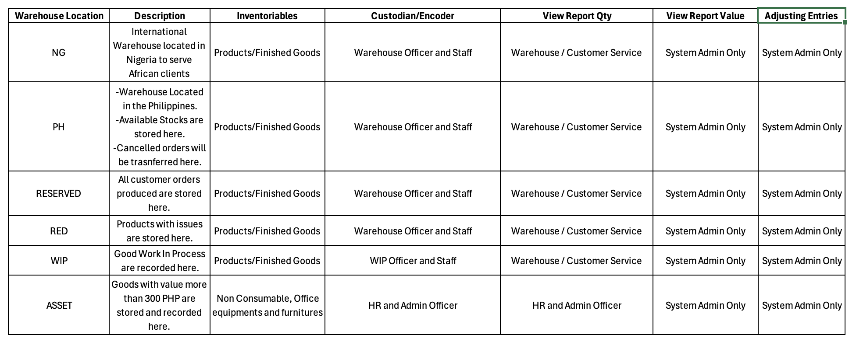

Reports Required:

1. Inventory Valuation per Warehouse
2. Movement of Goods can be filtered as to date, reference nos., product

**Payment Recording:**

1. Required Fields

* Date of Payment
* Sales Order No.
* Customer Code
* Method of Payment
* Status
* Receiving Account
* Payment Uploaded By
* Remarks

1. Reports Required:

* Payment Reports per Sales Order
* Customer Account Summary